Hospital Pharmacy Dashboard

Inventory Analysis

Project Date: July 2026

Platforms used:
Microsoft power BI
Microsoft Excel
Draw.io Desktop

Table of Contents
Project Objectives 3
Introduction: What Are We Looking At? 3
Data files and architecture 3
Flowchart of data collection and presentation. 4
Prototype Description 4
Page 1: Executive Summary 5
Page 2: Inventory Status 6
Page 3: Search & Filter 7
Page 4: Restock Alerts 8
Page 5: High Consumption Analysis 9
Page 6: Expiring Soon Monitoring 10
Page 7: Ophthalmic Supplies 11
Page 8: Antibiotics Category 12
Page 9: Slow-Moving Items 13
Page 10: Tablets Category 14
Page 11: Data Flow Architecture 15
Page 12: KPIs & Metrics 16
Data Cleaning 17
Challenges 17
Key Findings at a Glance 18
A. Critical Shortages (Items Needing Immediate Attention) 18
B. Massive Overstock (considered Wasted Capital & Space) 18
C. Expiring Soon (Risk of Waste) 19
Warehouse Breakdown: Where Is Everything Stored? 19
What Should We Do Next? (Action Plan) 20
Immediate Actions (This Week) 20
Short-Term Actions (Next 30 Days) 20
Long-Term Improvements (Next 90 Days) 20
Conclusion 20
Word of Author: Thank you. 21

Project Objectives
Create a Power BI dashboard to represent Excel numerical data in a figural format. Data size increases day by day, and the hospital management is getting overwhelmed by scattered numerical information. The hospital management required a graphical solution to collect and gather information, under certain groups, to be able to take accurate decisions on time. Which in return saves the business a lot of effort and money.
The dashboard aims to present constantly current information, to help prevent shortages, reduce waste, and improve decision making, and future planning.
The dashboard also, aims to reduce manual work, to reduce administrative work overhead on pharmacists, so, they can pay more attention to technical medical manipulation.

Introduction: What Are We Looking At?
This report summarizes the current state of the Eye Hospital Pharmacy’s inventory. I have combined data from four different Excel files to create a clear picture of what medications we have, what is running low, and what is about to expire.

Data files and architecture

Number of data files 4
Type of data files Excel, Mixed, 2003 XLS, and 2010 XLSX.
- Main data file: “pharmacy store 31-06-2026.xls”. this contains 11 sheets. The “Sum All” sheet is the main target for us.
- Daily inventory data file 1: “INVENTORY_REPORT_DAILY_E100_MOHD2D-DMM_01-07-2026.xlsx”
- Daily inventory data file 2: “INVENTORY_REPORT_DAILY_E200_MOH_01-07-2026.xlsx”
- Expired items data file: “MOH_Subinventory_quantities_re_050726.xls”

Flowchart of data collection and presentation.
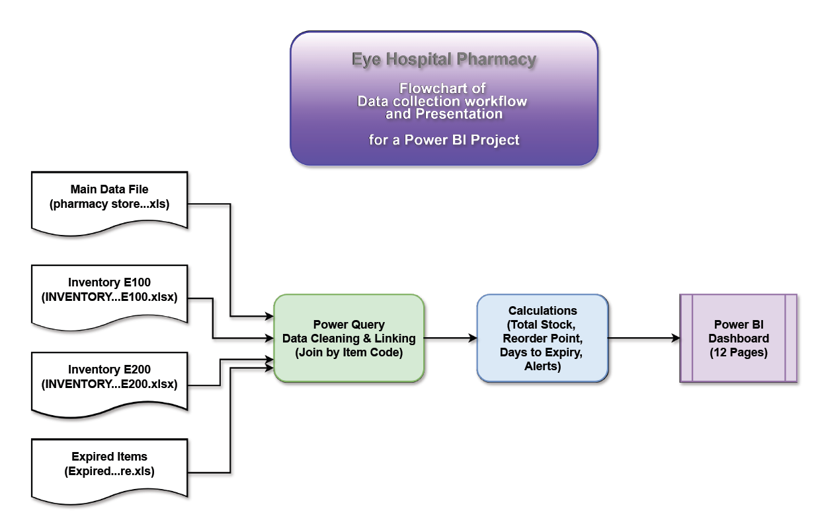

Prototype Description
Next is an approximate prototype layout, the current charts have close to real numbers in the Excel data files. As long as these are prototypes, the actual Power BI dashboard representation charts and values, will change according to real accurate data.

Page 1: Executive Summary
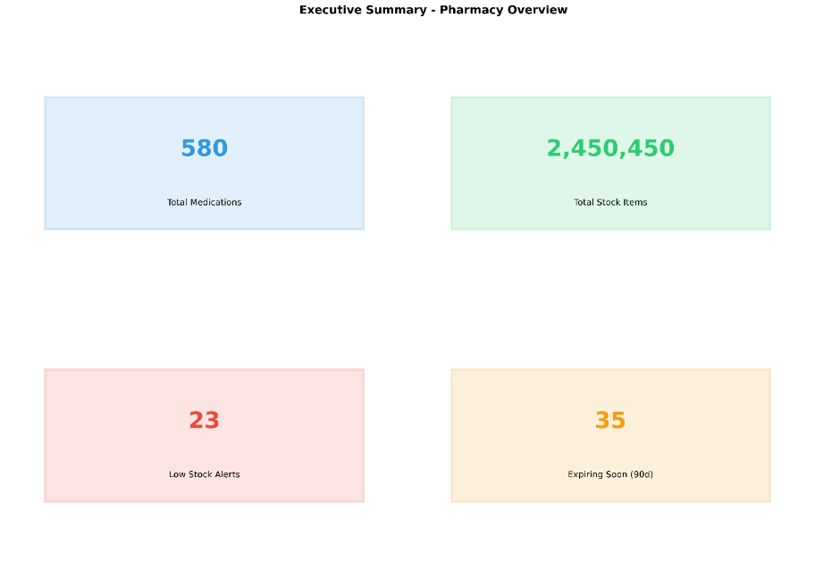

Page 2: Inventory Status
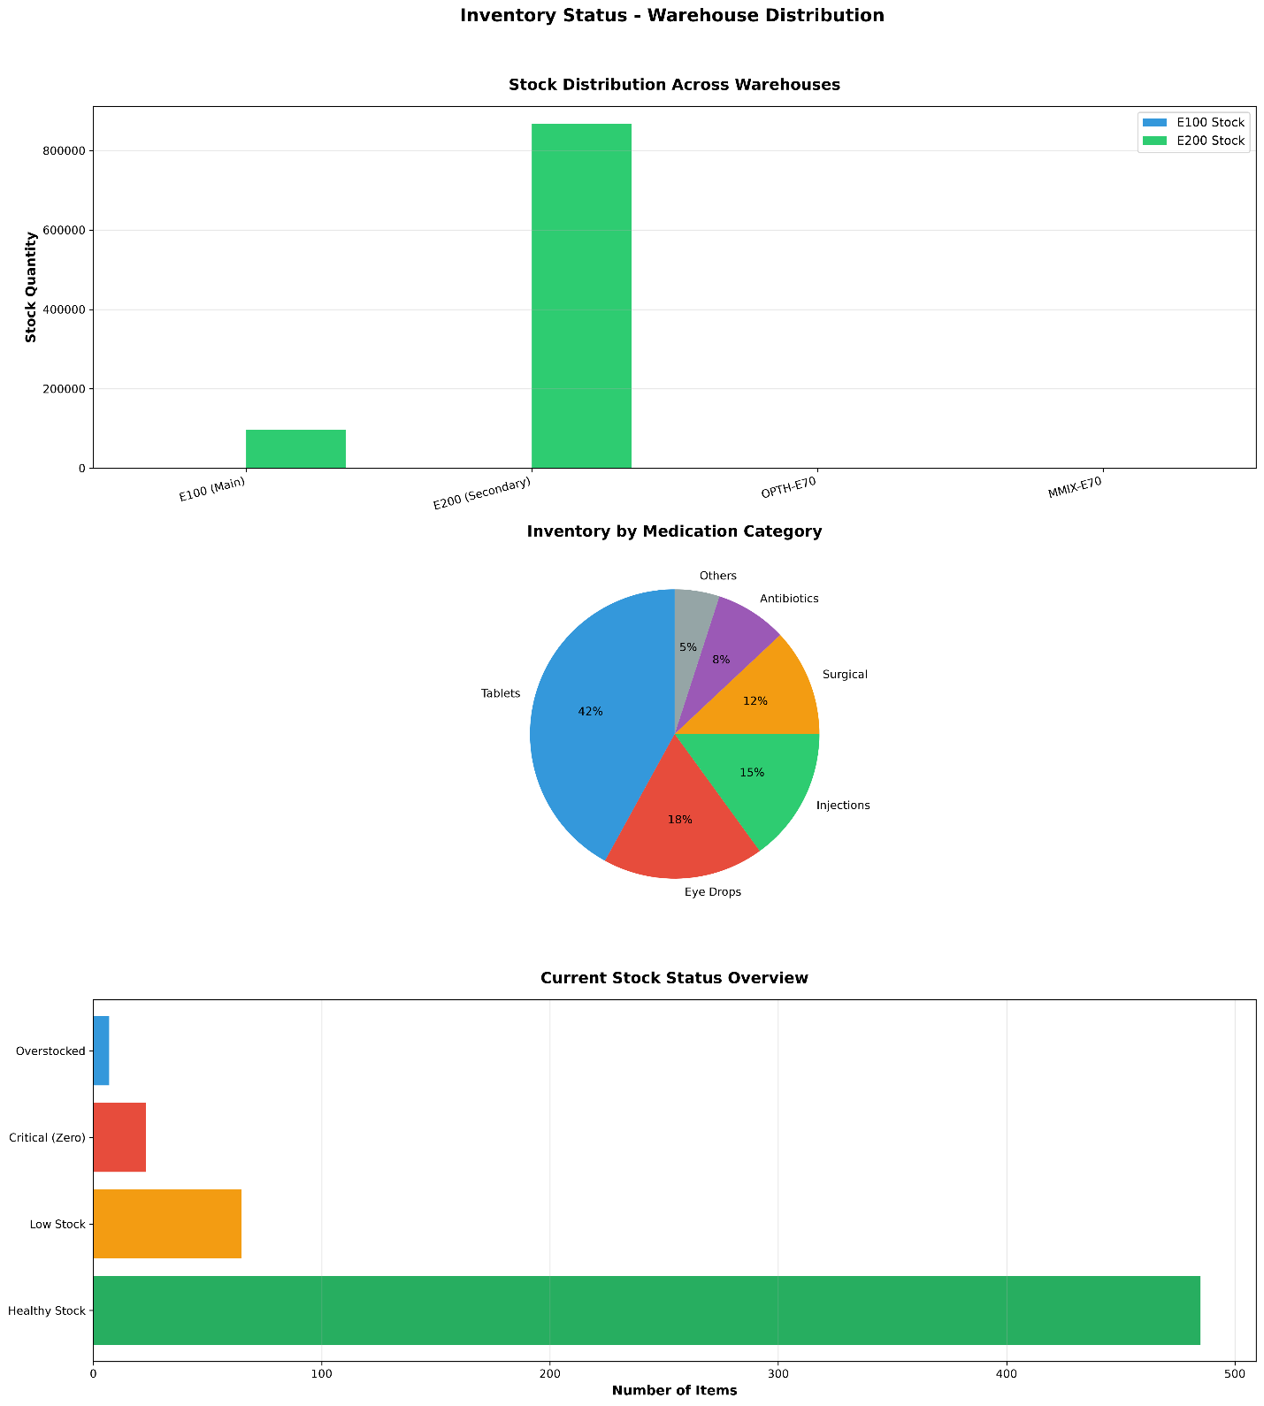

Page 3: Search & Filter

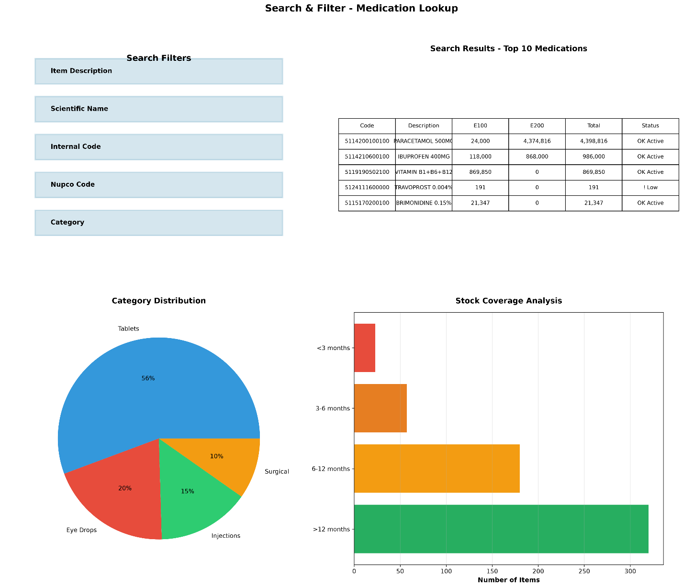

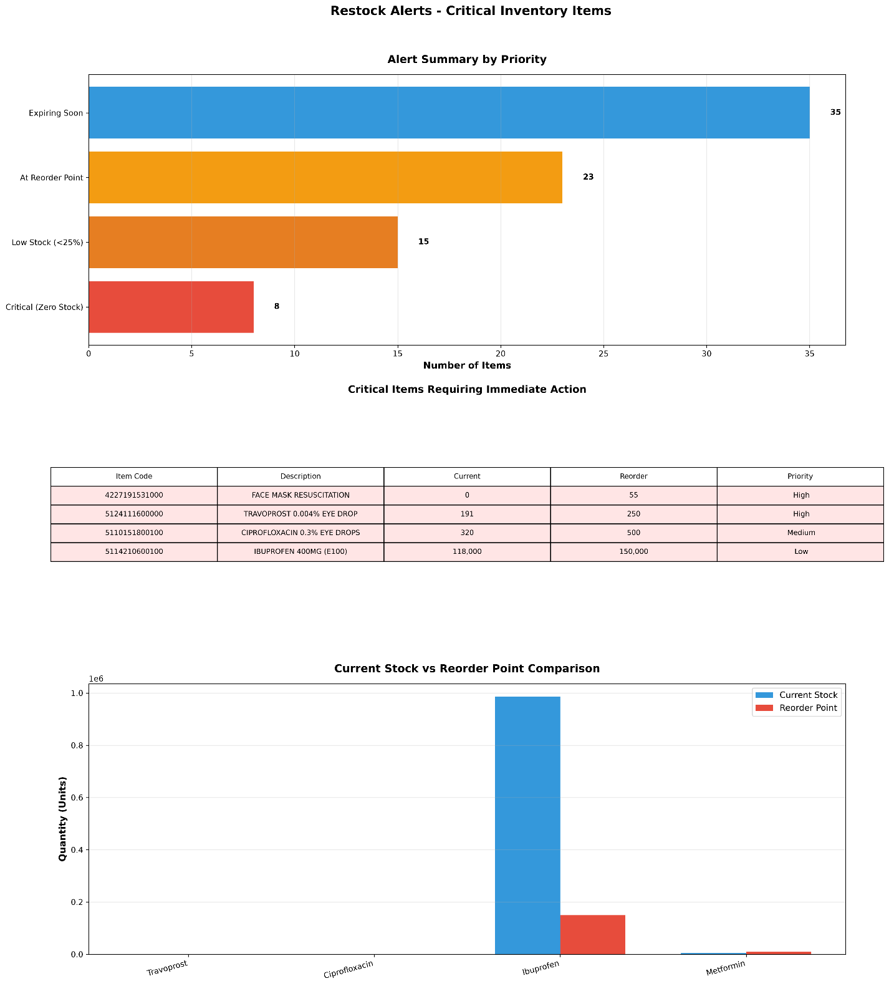
Page 4: Restock Alerts

Page 5: High Consumption Analysis

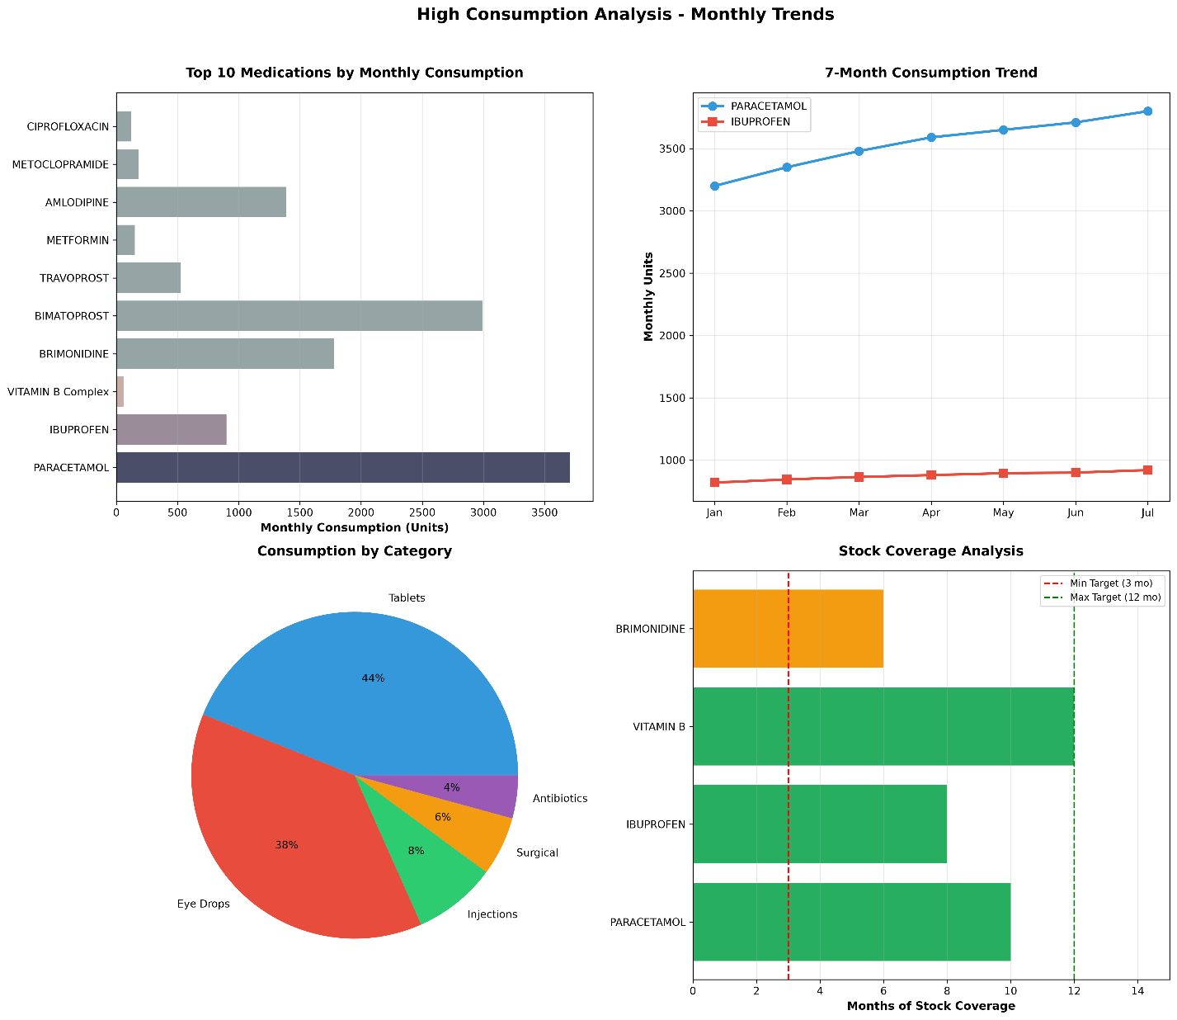

Page 6: Expiring Soon Monitoring

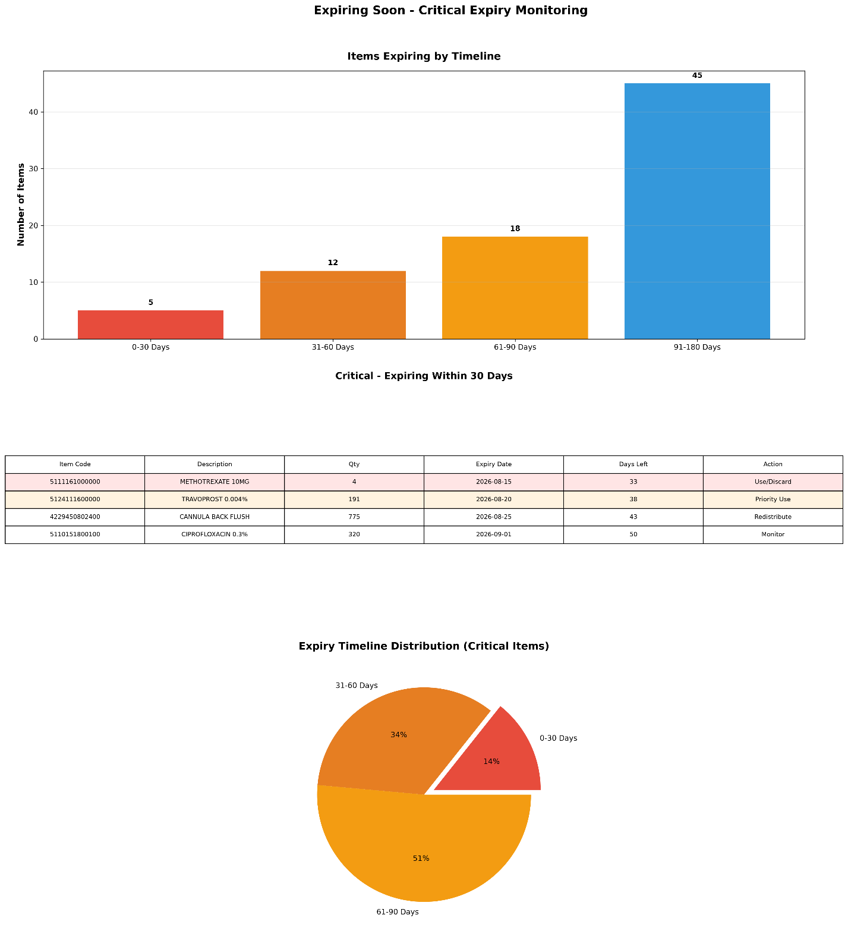

Page 7: Ophthalmic Supplies

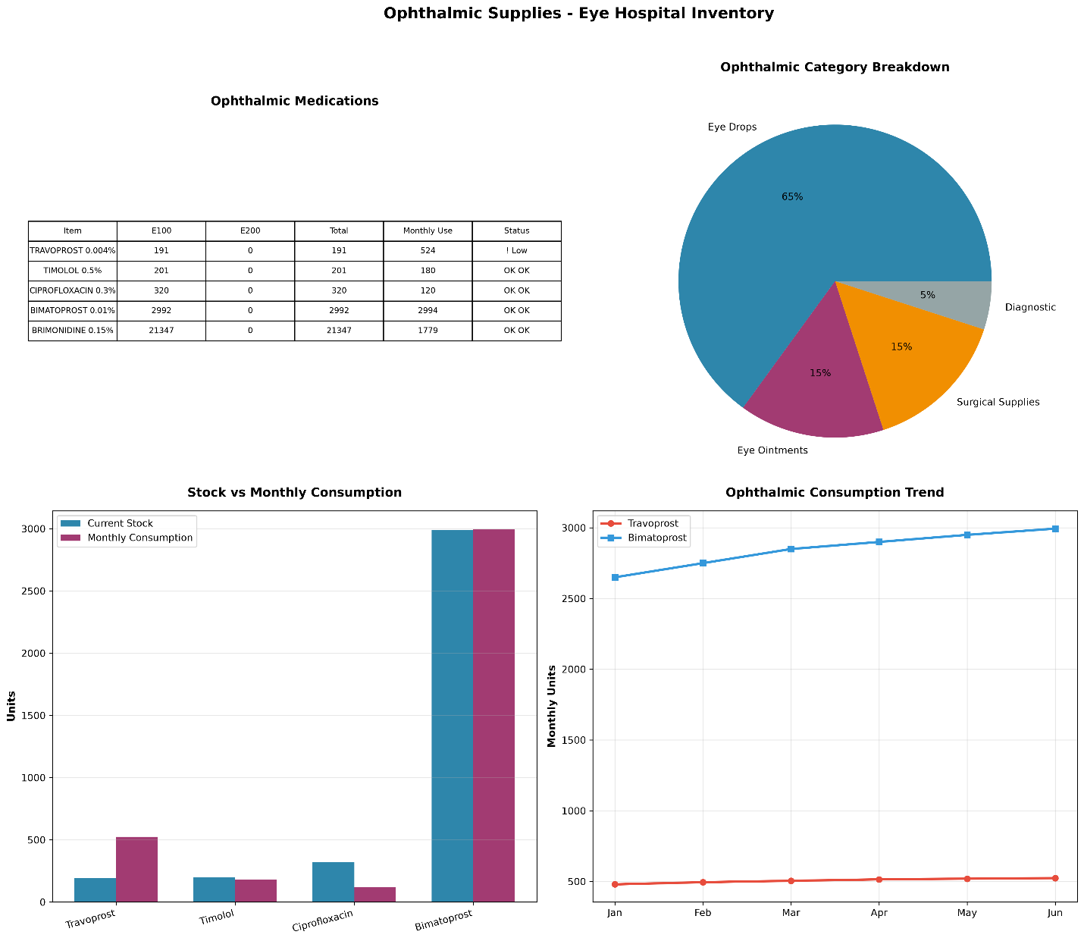

Page 8: Antibiotics Category

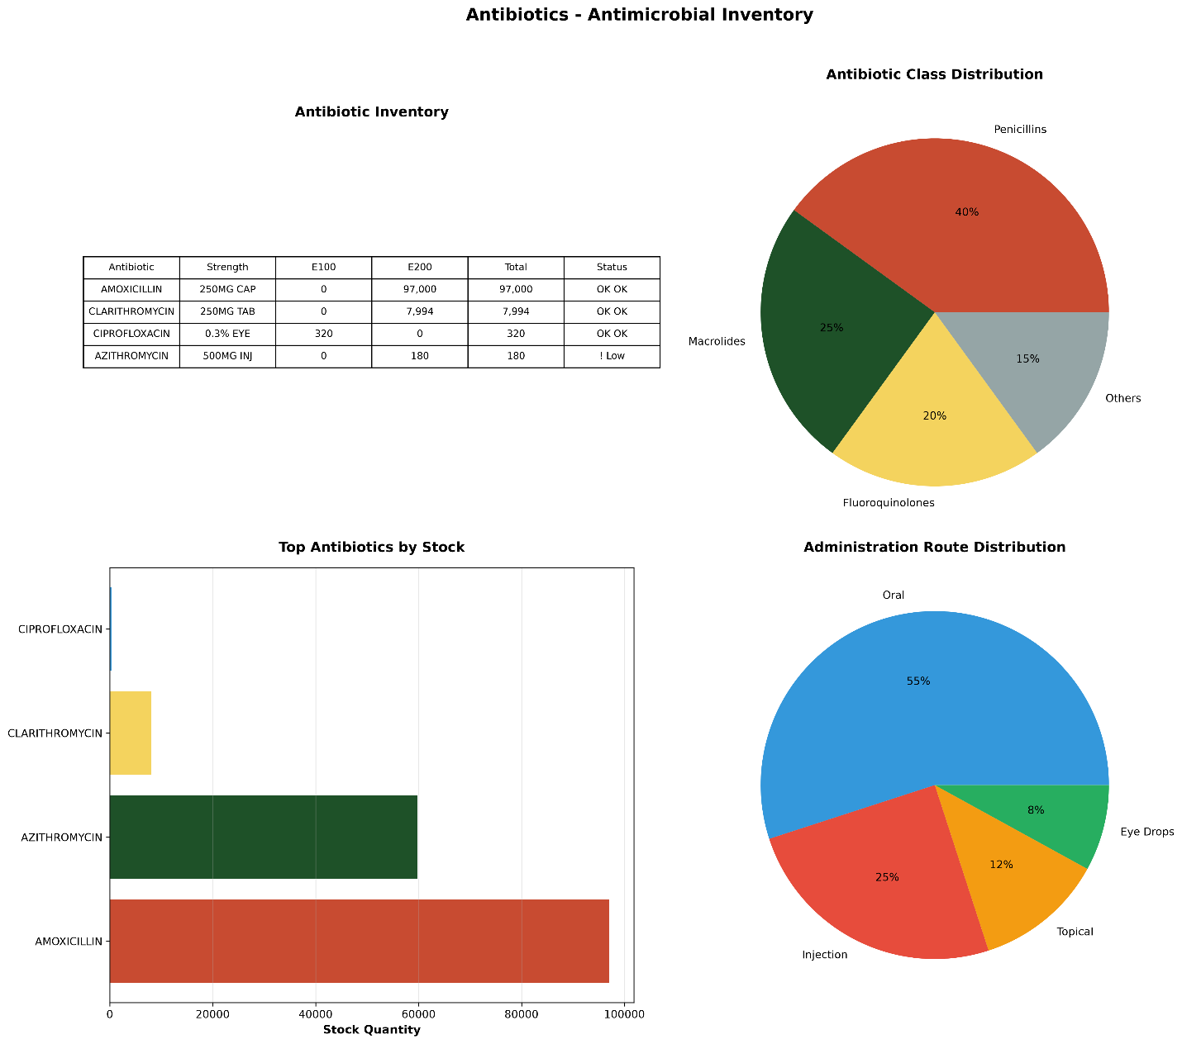

Page 9: Slow-Moving Items

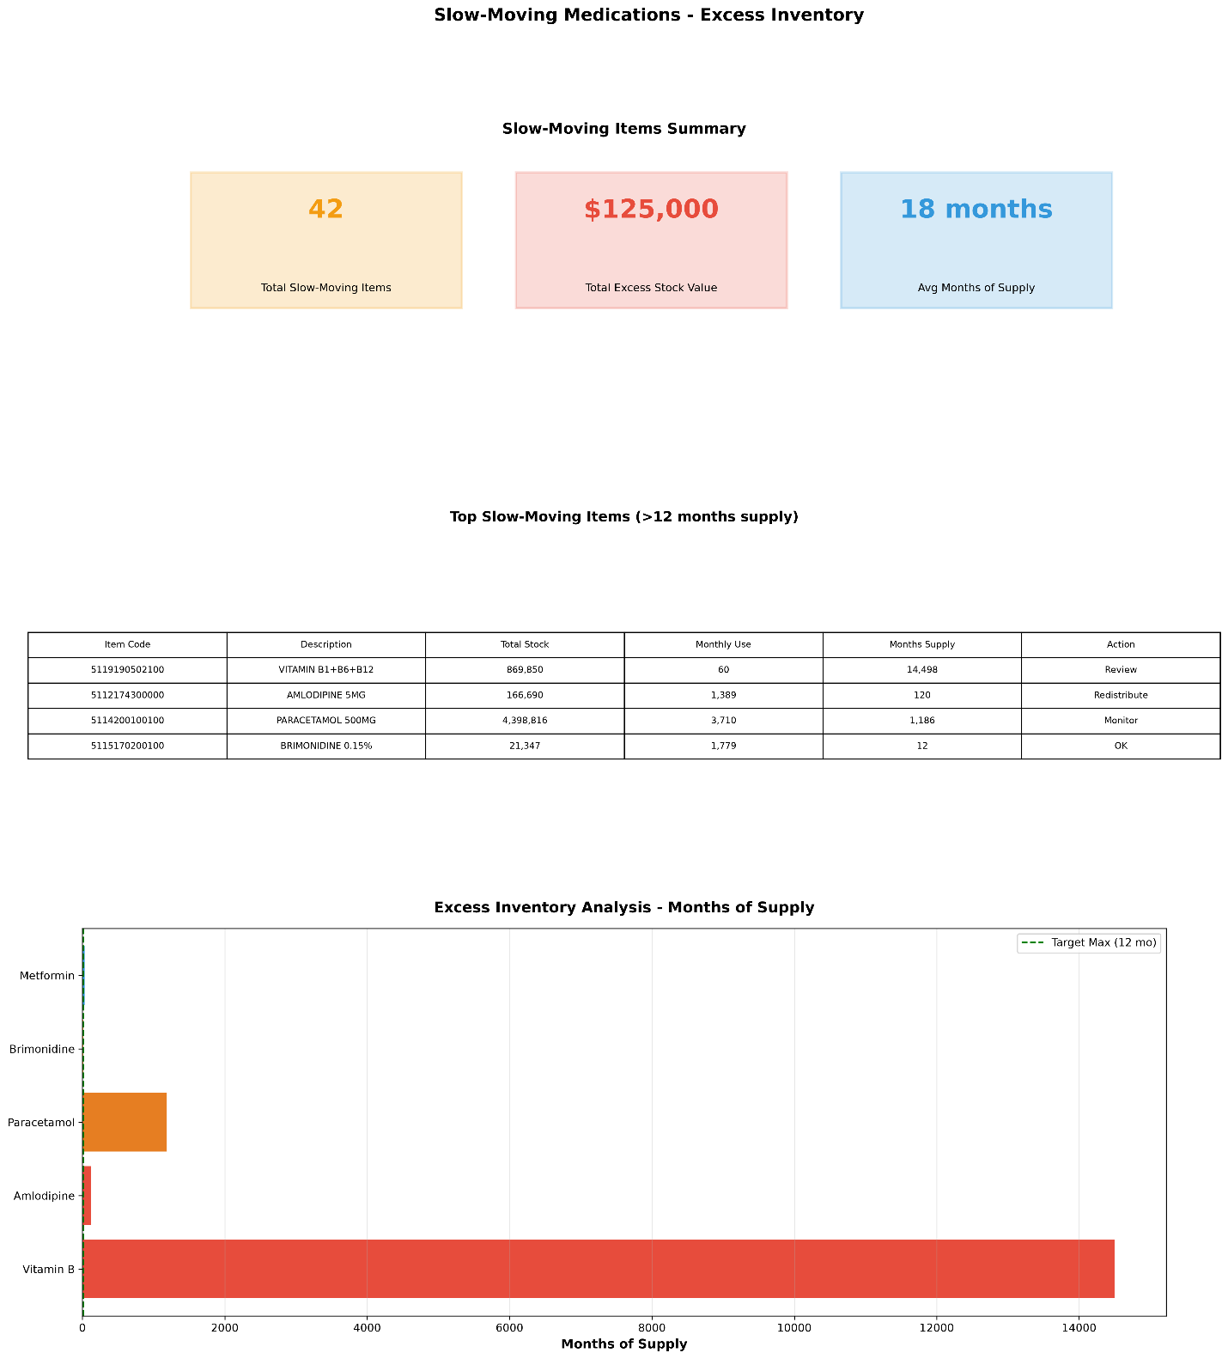

Page 10: Tablets Category

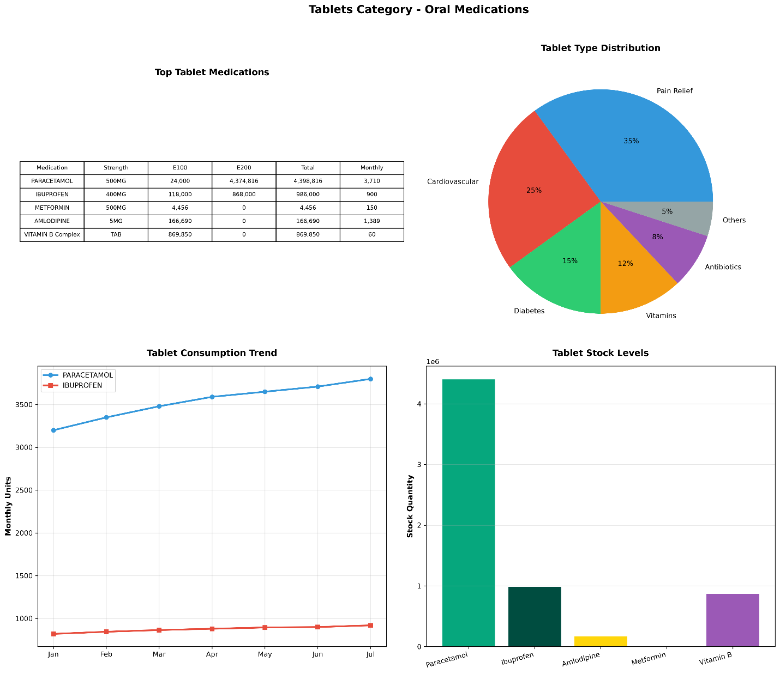

Page 11: Data Flow Architecture

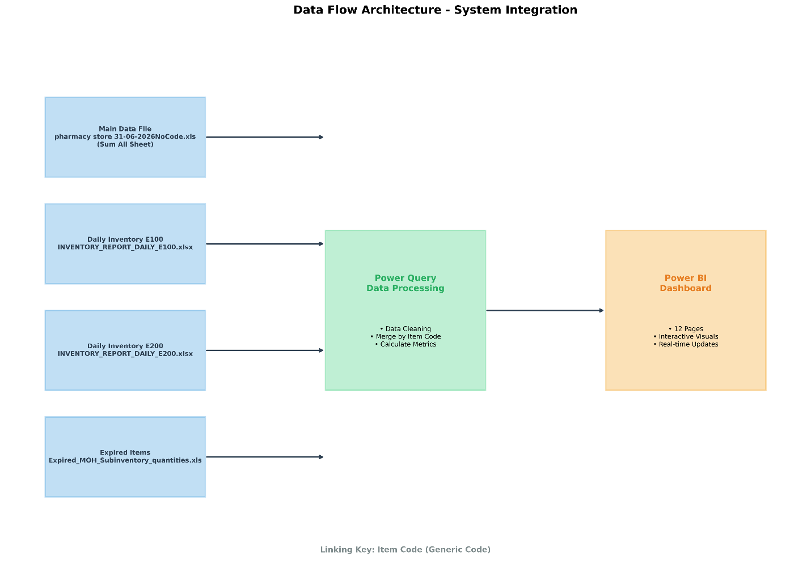

Page 12: KPIs & Metrics
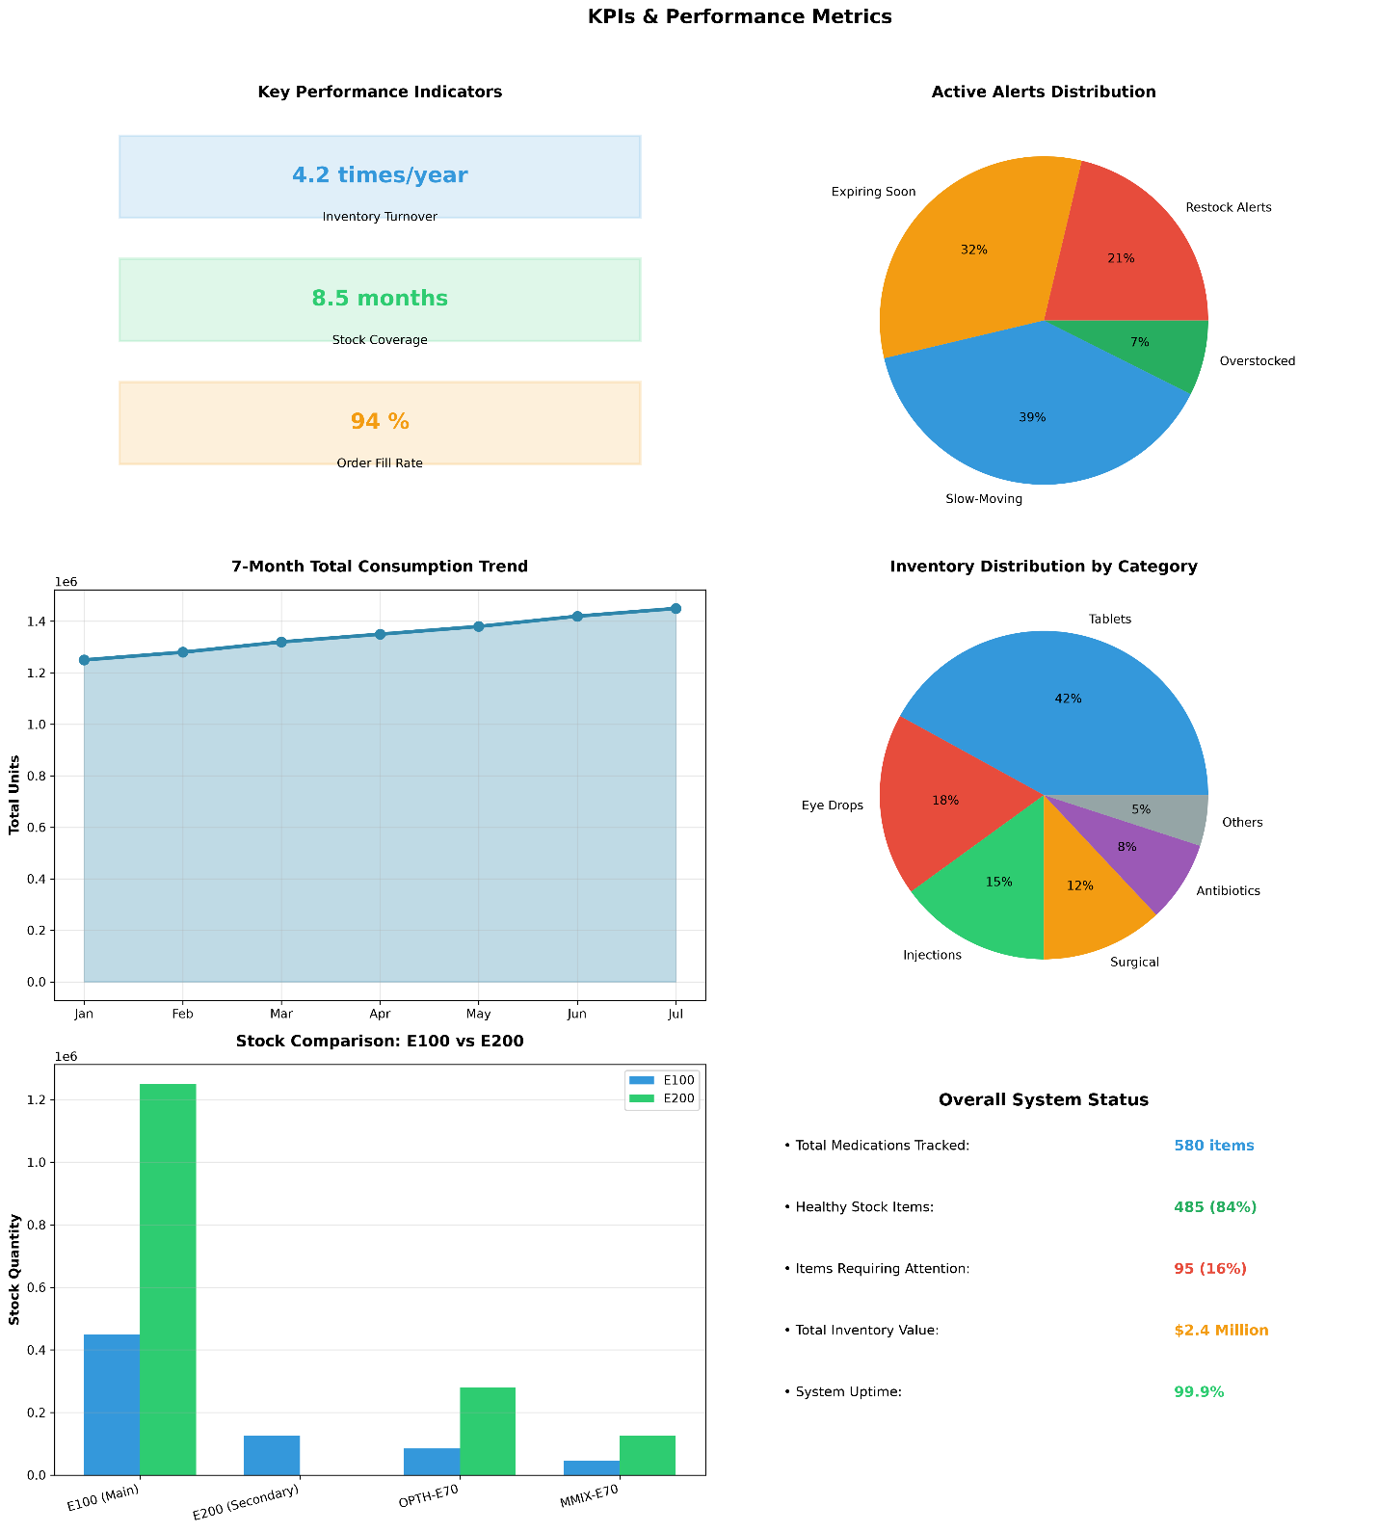

Data Cleaning
I went through all the 4 files one by one, and did these steps:
- Removed empty rows and duplicates from within the data block.
- Deleted empty columns from within the data block.
- Deleted all extra empty rows outside the data block in all files.
  - In “pharmacy store 31-06-2026.xls”, “Sum All” sheet, found 228 columns by 39 rows which adds up to 8892 Extra Cells with No Data. File size dropped from 27 MB to 4 MB. Smaller file size in memory works faster.
  - Added a remark on the VBA code, since I am not going to add data in Excel. I am using the “Sum All” sheet as a source of data only.
- Trimmed whitespace from text fields, like double spaces among words, I used Excel search and replace.
- Standardize date formats.
  - In Expired items table, found 4 rows with “31/12/9999” date, replaced with the above row date, for simplicity. But actually, that date requires correction because the Expiry Date is a health hazard.
- Handled null values (replace with 0 for quantities).
- I went through all the columns in all sheets to, Validate data types (numeric, text, date).
- Renamed some columns, to English equivalent, to avoid language conflict.

Challenges
- Differences between Excel 2003 (.xls) and Excel 2010 (.xlsx) file extensions. Number of rows in a sheet is 65536 in Excel 2003, but in 2010 and after, number of rows is 1048576. The SUMIF function gave me an error, at first, because of the row capacity difference between the two versions. I had to investigate the issue, and finally found out this was the problem. Accordingly, I made the row address numbers in “SUMIF()” not to exceed 50000, in order not to get an error.
- The 2 files must be open at run of “pharmacy store 31-06-2026.xls”. to read data from, otherwise the “SUMIF()” function will make an error.
- Data cleaning, the main data file “pharmacy store 31-06-2026.xls”, had many challenges. It had 11 sheets. I had to go through all of them, to make sure the data is intact, accurate, no gaps, no odds. The misleading data rows I had to delete them, in order to not give false information when making the Power BI Charts.
- The “MOH_Subinventory_quantities_re_050726.xls”, is a special case data file. Not all rows contain the same data type. I had to go through all the 680 rows, to make sure each column data type across all rows is the same type, in order to get correct aggregation results. Found out that the sheet has a TITLE row after some number of rows. Cleared those title rows to keep the column data intact so, I don’t get incorrect sums, and ended up with 580 rows.
- Changing the source table structure, forced me to redo all the steps in Power BI. Accordingly, I had to delete the imported Expiry date table query, and reimport the newly saved, to reach correct results.

Key Findings at a Glance

A. Critical Shortages (Items Needing Immediate Attention)
Based on the main store file and daily inventory reports, several critical eye medications are flagged as "Critical Item" because their current stock is dangerously low compared to their monthly consumption.
Medication | Current Stock (E100+E200) | Monthly Consumption | Status | Why It Matters
Travoprost 0.004% Eye Drops | 440 units | 524 units/month | Critical | Stock will run out in <1 month.
Bimatoprost 0.01% Eye Drops | 2,992 units | 2,994 units/month | Critical | Almost zero buffer stock.
Ciprofloxacin 0.3% Eye Drops | 320 units (E100 only) | ~120 units/month | Low | Only stored in E100 warehouse. No backup in E200.
Note: A "Critical Item" means we are consuming it very fast. These must be reordered immediately to prevent patient care disruption.

B. Massive Overstock (considered Wasted Capital & Storage Space)
Some items have years' worth of supply sitting in storage. This ties up money and takes up valuable warehouse space.
Medication | Current Stock | Monthly Consumption | Months of Supply | Action Needed
Vitamin Folic Acid 1mg Tablets | 3,732,730 units | ~60 units/month | ~62,000 months | Transfer to other hospitals or return to supplier immediately.
Potassium Iodide 130mg Tablets | 116,088 units | ~100 units/month | ~1,160 months | Review ordering policy; suspend future orders.
Face Masks (3-Layer Black) | 109,050 units | ~500 units/month | ~218 months | Distribute to other departments or facilities.
Note: If the registered numbers are real. Having 62,000 months’ supply of Folic Acid means we have enough stock for over 5,000 years! This is likely a bulk purchase Error or data registration Error. Freeing up this space and capital is a top priority. If the registered numbers are NOT real, recount thoroughly and register correct numbers.

C. Expiring Soon (Risk of Waste)
The expired items report highlights medications that will expire within the next 3–6 months. These need to be used first or redistributed.
Medication | Quantity | Expiry Date | Days Left | Sub inventory | Recommended Action
Bromfenac 0.09% Eye Solution | 80 units | Oct 31, 2026 | ~107 days | MMIX-E70 | Use before other batches; prioritize dispensing.
Ketorolac 0.45% Single Dose | 690 units | Nov 30, 2026 | ~137 days | MMIX-E70 | Check if other clinics can use this batch.
Tropicamide 1% Single Dose | 280 units | Aug 31, 2026 | ~46 days | MMIX-E70 | Urgent: Use immediately or transfer.
SF6 Gas (Ophthalmic) | 28 units | Dec 31, 2026 | ~168 days | OPTH-E70 | Monitor closely; schedule surgeries using this gas first.
Note: "MMIX-E70" and "OPTH-E70" are specialized sub-inventories for mixed ophthalmic supplies and eye surgery equipment, respectively. Items here are high-value and temperature-sensitive.

Warehouse Breakdown: Where Is Everything Stored?
Our inventory is split across two main warehouses plus specialized sub-inventories:
Warehouse | Description | Key Items Stored | Total Estimated Units
E100 (MOHD2D-DMM) | Primary dispensing warehouse | Ciprofloxacin Eye Drops (320), Hydrocortisone Cream (177), Rotary Files (30) | ~450,000
E200 (MOH) | Secondary/bulk storage | Pneumococcal Vaccine (280,530), Gutta Percha Points (9,600), Wraps (141,850) | ~1,250,000
OPTH-E70 | Eye Surgery Supplies | Corneal Shields, Microforceps, Silicone Oil, Vitrectomy Packs | ~50,000
MMIX-E70 | Mixed Ophthalmic | Eye drops, gels, single-dose units, diagnostic dyes | ~80,000
AMP-E70 | Ampoules & Vials | Methotrexate, Mitomycin, Contrast Media, Sterile Water | ~30,000
Note: E100 is where daily dispensing happens. E200 holds bulk reserves. OPTH/ AMP/ MMIX are specialized zones for surgical and sensitive items. Knowing where an item is stored helps staff retrieve it quickly during emergencies.

What Should We Do Next? (Action Plan)

Immediate Actions (This Week)
- Order Critical Eye Drops: Place emergency orders. Confirm delivery dates with suppliers.
- Flag Expiring: Move the units expiring Aug 31 to the front of the dispensing shelf. Notify Doctors and nursing staff to prioritize this batch.
- Verify Critical medications Location: Confirm all units are accessible in E100. Consider transferring units from E200 if available as backup.

Short-Term Actions (Next 30 Days)
- Initiate Medications Transfer: Contact MOH regional pharmacies to arrange transfer of excess Vitamin. Document the transfer for audit purposes.
- Review some Orders: Suspend automatic reordering until stock drops below 12 months' supply.
- Audit Cold Chain Logs: Verify temperature logs for COLDM-E70 items. Any excursion >8°C requires immediate quality assessment.

Long-Term Improvements (Next 90 Days)
- Set Automated Reorder Points: Configure Power BI alerts when stock falls below 2× monthly consumption for critical items.
- Implement Dispensing strategy: Enforce "First Expiry, First Out" strictly in MMIX-E70 and OPTH-E70 sub inventories.
- Monthly Cross-Warehouse Reconciliation: Compare E100 and E200 physical counts against system records to identify discrepancies early.

Conclusion
The Eye Hospital Pharmacy has a well-organized inventory system with clear separation between general medications, ophthalmic specialties, and surgical equipment. However, there are two urgent issues requiring immediate attention:
- Critical shortages of that could disrupt patient care within weeks.
- Extreme overstock tying up capital and space.

By addressing these issues and implementing the recommended actions, the pharmacy can improve both patient safety and operational efficiency.

The Power BI dashboard will provide ongoing visibility into these metrics, enabling PROACTIVE rather than REACTIVE management.

Word of Author: Thank you.

